NOTICE OF INTENT TO REQUEST RELEASE OF FUNDS

January 31, 2025
City of Cranston
845 Park Avenue
Cranston, RI 02910
(401)-461-1000

ON or about February 8, 2025 the City of Cranston, Rhode Island, will submit a request to the U.S. Department of Housing and Urban Development for the release of Community Development Block Grant funds under Title I of the Housing and Community Development Act of 1974 (PL-93-383), as amended, to undertake the following projects:

Housing Rehabilitation Loans for the purpose of:
Provide low-interest loans for eligible owner-occupied housing rehabilitation, specifically:

- Plantation Drive – A single family residence. Entire project consist of 3 repairs.

Project will consist of installing vinyl siding on exterior of home, replace 2 exterior windows and 2 exterior doors. We will also replace all gutters and downspouts. All old vinyl siding and backerboard will be removed. New vinyl siding will be installed over dow styrofoam . All fascia, windows, door trim will be covered with white coil stock. Use at least .044 millimeter-thick siding and components. Install j blocks and split blocks under and around all fixtures. Cover all soffits with vinyl soffit material vented every 4 feet. Homeowner to select siding and trim color. We will remove 4 existing small windows and install 2 double hung larger windows with screens. U-factor .32 or less. Paint interior trim white. 2 Exterior doors will be removed and install 2 fiberglass insulated doors includes new casings. Paint trim white. All existing gutters and downspouts will be removed and new white seamless gutters, downspouts and elbows installed.

Total of ………………………………………………………………………………….……..$24,900

The activities proposed are categorically excluded under HUD regulations at 24 CFR Part 58 from National Environmental Policy Act requirements. An Environmental Review Record (ERR) that documents the environmental determinations for these projects are on file at the Cranston Dept. of Community Development, 35 Sockanoset Cross Road, Ste. 6, where the ERR can be examined or copied weekdays 8:30AM. to 4:30PM.

Public Comments

Any individual, group, or agency may submit written comments on the ERR to Ernest Tommasiello, etommasiello@cranstonri.org, Cranston Dept. of Community Development, or call 401-780-6240. All comments received by February 7, 2025 will be considered by the City of Cranston prior to authorizing submission of a request for release of funds.

Environmental Certification

The City of Cranston certifies to HUD that Kenneth J. Hopkins, in his capacity as Mayor consents to accept the jurisdiction of the Federal Courts if an action is brought to enforce responsibilities in relation to the environmental review process and that these responsibilities have been satisfied. HUD’s approval of the certification satisfies its responsibilities under NEPA and related laws and authorities and allows the City of Cranston to use Program funds.

Objection to Release of Funds
HUD will accept objections to its release of funds and the City of Cranston’s certification for a period of fifteen days following the anticipated submission date or its actual receipt of the request (whichever is later) only if they are on one of the following bases: (a) the certification was not executed by the Certifying Officer of the City of Cranston; (b) the City of Cranston has omitted a step or failed to make a decision or finding required by HUD regulations at 24 CFR Part 58; (c) the grant recipient or other participants in the development process have committed funds or incurred costs not authorized by 24 CFR Part 58 before approval of a release of funds by HUD; or (d) another Federal agency acting pursuant to 40 CFR Part 1504 has submitted a written finding that the project is unsatisfactory from the standpoint of environmental quality. Objections must be prepared and submitted in accordance with the required procedures (24 CFR Part 58, Sec. 58.76) and shall be emailed to CPDRROFBOS@hud.gov. Potential objectors should contact HUD to verify the actual last day of the objection period.

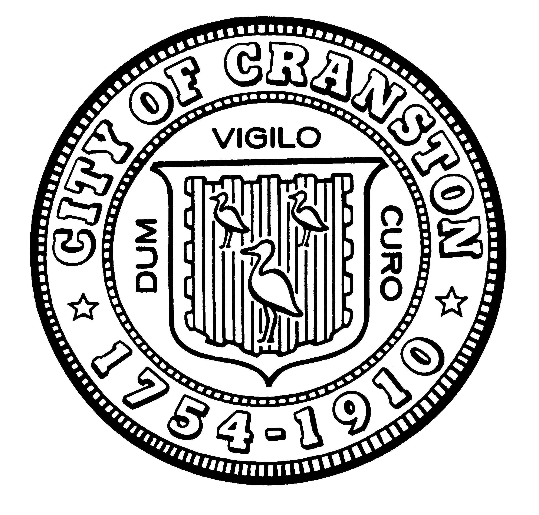
Kenneth J. Hopkins Ernest Tommasiello
Ma Mayor, Certifying Officer Director, Community Development

